**DEVIATORE DI FLUSSO A TRE VIE R3V – CORPO DI GHISA**

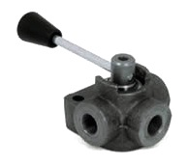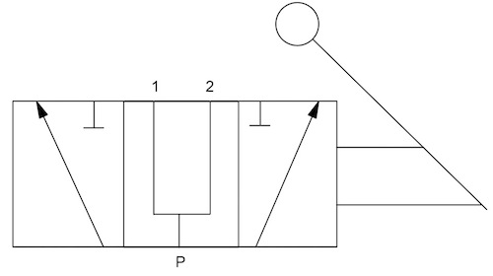

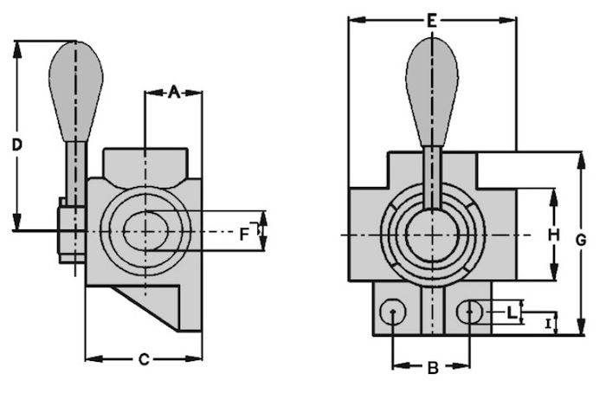

| **Codice** | **Filettatura F** | **Pressione max. di esercizio** | **Dimensioni  mm** | | | | | | | | |
| --- | --- | --- | --- | --- | --- | --- | --- | --- | --- | --- | --- |
| **pollici** | **bar** | **A** | **B** | **C** | **D** | **E** | **G** | **H** | **I** | **L** |
|  | 1/4” | 300 | 21 | 25 | 45 | 110 | 74 | 78 | 32 | 11 | 8,5 |
|  | 3/8” | 300 | 21 | 25 | 45 | 110 | 74 | 78 | 32 | 11 | 8,5 |
|  | 1/2” | 250 | 25 | 32 | 53 | 120 | 86 | 95 | 40 | 17 | 11 |
|  | 3/4” | 220 | 29 | 32 | 61 | 125 | 90 | 100 | 46 | 17 | 11 |
|  | 1” | 220 | 40 | 32 | 66 | 130 | 96 | 110 | 55 | 19 | 11 |